Windows password Hashes:
Stored hashed user account in SAM (security accounts manager) database.
When user account is created Automatically hashed.

Authentication and verification if user credential done by local security authority (LSA)
Process lsass.exe

LM is disabled from window vista onward.
NTLM hash /NT hash (version 1 /version 2)
NT (New Technology) LAN Manager (NTLM)
SAM database:
User account and password are stored in SAM are hashed by default.
Sam database cannot be copied while OS is running.

Window nt (kernel) keep sam file locked and as a result attacker utililze in-memory technique and tools to dump hashes from lsass process.
Tools = mimikat etc.
In modern version. sam is encrypted with syskey.

LM (Lanman):

Lm is not case sensitive.
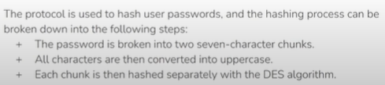
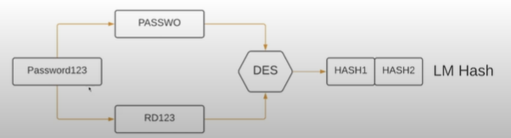

NTLM (NTHash):

Encrypted with MD4 hashing algorithm.
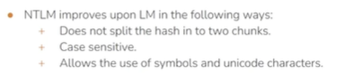

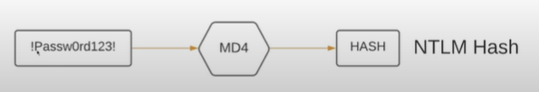

Note:
Elevated privilege to access the lsass process.
Both stored in the SAM and both doesn’t contain the password salts.
Therefore it is Cracked easily by brute-forece attack or rainbow table attack.
Dump tools mimikat or window credential editor.
Finding credential in window configuration file which is windows vulnerability.

